Favorite Hobbies for Students in the Emirates of Abu Dhabi

Name:
Institution:
Professor:
Course:
Date:

Table of Contents
TABLE OF CONTENTS..................................................................................................... 2
INTRODUCTION ..................................................................................................... 3
LITERATURE REVIEW ..................................................................................................... 3
Research Question ..................................................................................................... 3
METHOD ..................................................................................................... 4
Participants ..................................................................................................... 4
RESULTS ..................................................................................................... 5
Data Analysis ..................................................................................................... 8
CONCLUSION ..................................................................................................... 9
REFERENCES ..................................................................................................... 10

INTRODUCTION
Hobbies play an important role in our lives because they are a source of joy and enrichment. They offer people an opportunity to learn new skills. Having hobbies offers an opportunity to spend time consciously and productively. Trying something new every time is important because it helps in personal exploration. When an individual has a certain hobby, they are motivated to act in a certain way, which portrays their personality (Halen, 2017). There are several benefits that are associated with hobbies, including relieving stress, cultivating patience, improve social life, boost self-esteem, offers new perspectives, prevents bad habits, helps in development of new skills, and knowledge. Examples of hobbies can include reading, watching movies, cooking, gardening and cycling. For college students, hobbies are important because they enhance their ability to become better performers in class. This paper aims at identifying the favorite hobby among students in the Emirates of Abu Dhabi. Also, the paper will explore the differences that exist between males and females using the PISA student questionnaire data.
Research question
What are the attitudes of students in Abu Dhabi towards reading? Do these attitudes determine their academic performances?
LITERATURE REVIEW
Hobbies play an important part in the improvement of a person’s life. Having hobbies is necessary because it acts as an opening for an individual to know himself/ herself better. According to Becket and Taylor (2016), hobbies can help an individual grow and develop into a more productive and self-conscious person. Hobbies are activities that a person does out of their own free will and are expected to bring joy and amusement. There are other researches that consider hobbies as alternative activities. In this context, these activities are those that a person engages in when they are not doing their routinely work. Alternative activities are aimed at helping a person become better in different areas (Becket and Taylor, 2016). for example, a person may desire to be competent in sports. This alternative activity would be achieved through experimentation. Alternative activities, therefore, are aimed at adding value or increasing an individual’s competitiveness in a certain area.
Engaging in a particular hobby is considered beneficial. One of the benefits is that hobbies are used to relieve stress (Becket and Taylor, 2016). Engaging in an activity that you love and doing it at will results to joy and fulfilment. Hobbies help a person shift their attention from the challenges of a day, instilling them with happiness. Another benefit is that they help a person to become patient in life. The time an individual takes to learn a new hobby portrays their patience because it takes time to learn a new skill. Hobbies are used to boost confidence (Halen, 2017). When a person does something they love, they can do it excellently and with confidence. Working with confidence can enhance the achievement of goals. Hobbies are associated with learning new skills and increasing knowledge.
METHOD
Quantitative research methods will be used to gather results for this study. Quantitative research methods focus on quantifying a problem by providing quantified data that can be translated into meaningful statistics. Quantitative research methods are structured and can include surveys, systematic observations, interviews, online polls, and questionnaires (Oh, 2014).
Different factors will be put into consideration in the process of conducting this research. The rights of the participants will be protected by ensuring that the research is ethical. Participants will be required to sign an informed consent, provided with the right to withdraw from the study, and avoid unethical behaviors.
Closed-ended questionnaires were used in this research to collect data on students’ favorite hobbies. The questionnaire had four items, that is, strongly disagree, disagree, agree, and strongly agree.
Participants
The population used in the research will be carefully selected to ensure that the objectives of the research are met. A randomized sampling technique will be employed to ensure that the research has an equal representation of the study population. Additionally, a random sampling technique will ensure that all study groups are included, thus promoting the achievement of reliable results. An adequate sample size will be used in the research to ensure that the results obtained are conclusive. Besides, an adequate number of participants is important because it will ensure that the results are generalized. Sample size used is 7115 students in Abu Dhabi.
RESULTS
The results of the research are as shown below.

Table 1
Statistics of 7115 students in Abu Dhabi showing mean, median, mode, and standard deviation.
How much do you agree or disagree? Reading is one of my favorite hobbies.
Statistics
How much do you agree or disagree? Reading is one of my favorite hobbies.
N | Valid | 2558
N | Missing | 363
Mean |  | 2.78
Std. Error of Mean |  | 0.019
Median |  | 3.00
Mode |  | 3
Std. Deviation |  | 0.939
Variance |  | 0.881
Range |  | 3
Minimum |  | 1
Maximum |  | 4
Sum |  | 7115
Percentiles | 25 | 2.00
Percentiles | 50 | 3.00
Percentiles | 75 | 3.00

Table 2
Showing valid questionnaire responses for students in Abu Dhabi.
 |  | no. of students | % of the total population | % of the valid population | cumulative % of the valid population
Valid | Strongly disagree | 298 | 10.2 | 11.6 | 11.6
Valid | Disagree | 573 | 19.6 | 22.4 | 34.1
Valid | Agree | 1077 | 36.9 | 42.1 | 76.2
Valid | Strongly agree | 610 | 20.9 | 23.8 | 100.0
Valid | Total | 2558 | 87.6 | 100.0
Missing | No Response | 317 | 10.9
Missing | System | 46 | 1.6
Missing | Total | 363 | 12.4
Total |  | 2921 | 100.0

Chart 1
Frequency of students on how much they agree or disagree that reading is one of their favorite hobbies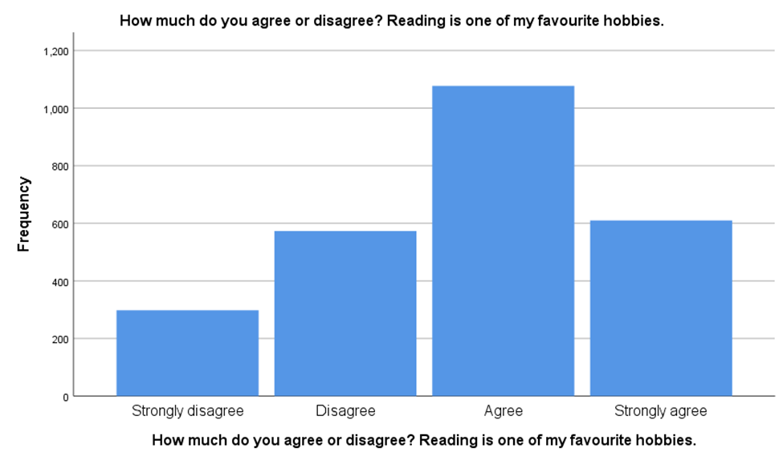
Chart 2
Mean of female and male who agree reading is one of their favorite hobbies
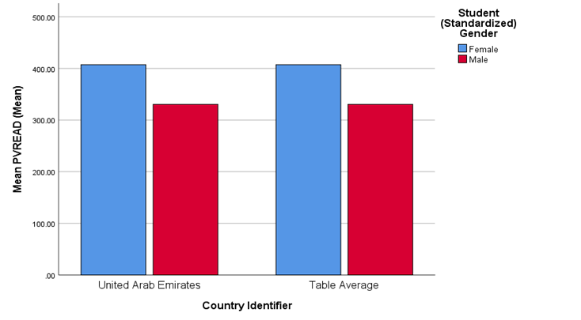
Chart 3
Mean of students on how they agree and disagree that reading is one of their favorite hobbies
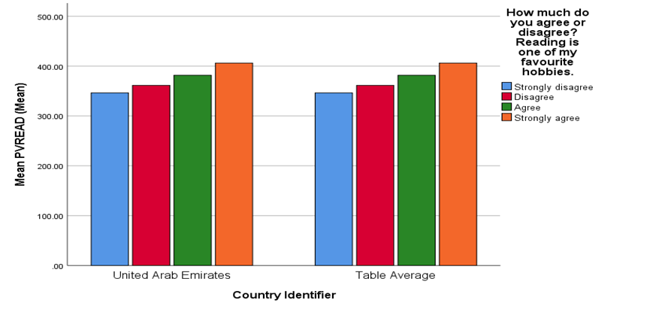
Data Analysis
Table 1 shows the statistics of all students who took part in the study. The research included 7115 students in Abu Dhabi. The table shows that the valid results used to make a decision about favorite hobbies were 2558 with 363 missing. The mean response rate was 2.78 with a standard deviation of 0.939.
Data in Table 2 shows how the valid results were distributed. The responses were distributed in four items. 298 of the valid participants strongly disagreed that reading was one of their favorite hobbies. This was 11.6% of the valid participants and 10.2% of the total participants. 573 students disagreed that reading was one of their favorite hobbies, which was 22.4% of the valid participants and 19.6% of the total participants. 1077 students agreed that reading was one of their favorite hobbies, which was 42.1% of the valid participants and 36.9% of the total participants. 610 strongly agreed that reading was one of their favorite hobbies. This value was 23.8% of the valid participants and 20.9% of the total participants. 317 participants did not respond to the question while 46 were not included in the system. From the table, it can be identified that majority of the participants (36.9%) agreed that readding was one of their favorite hobbies. The least percentage 10.2% strongly disagreed that learning was one of their favorite hobbies.
Chart 1 shows that the majority of the students in Abu Dhabi consider reading one of their favorite hobbies. The highest frequency is for students who agreed while the lowest frequency is for students who strongly disagreed.
Chart 2 shows data about gender. From the data, more females agreed that reading was one of their favorite hobbies compared to male students. Female students have a higher mean PVREAD compared to male students.
Chart 3 shows the average number of students who strongly disagree, disagree, agree, and strongly agree that reading is among their favorite hobbies. This chart shows that majority of students, both males and females in Abu Dhabi consider reading a favorite hobby.
CONCLUSION
Students have different hobbies with reading being one of their best. From the research, it was identified that most of the students from Abu Dhabi prefer to read as one of their hobbies. Also, the research shows that female students prefer reading to be a hobby than male students.

References
Becket, C., & Taylor, H. (2016). Human growth and development. 3rd ed. London: SAGE.
Halen, M. (2017). Experiences of Hobbies among the Youth: Bachelor Thesis.
Oh, J. H. (2014). Research methods. https://gsis.korea.ac.kr

